Wack-A-Mole Game with HTML, Tailwindcss and Typescript

The design part:
Code:
<!DOCTYPE html>
<html lang="en">
<head>
<meta charset="UTF-8">
<meta name="viewport" content="width=device-width, initial-scale=1.0">
<title>Document</title>
<link rel="stylesheet" href="input.css">
<style>
.mole {
background-size: 8rem;
background-image: url(
"https://media.geeksforgeeks.org/wp-content/uploads/20231130123541/mole.png")
}

</style>
</head>
<body class="pt-10 bg-amber-200">
<p class="text-center">Score: <span class="score-value">0</span></p>
<p class="text-center">Time: <span class="time-value">60</span>s</p>
<div class="flex justify-center items-center mt-5 flex-col gap-4">
<input type="button" value="Start Game" class="start-button bg-gray-100 py-2 px-4 rounded-lg hover:cursor-pointer hover:bg-slate-200"/>
<input type="button" value="End Game" class="end-button py-2 px-4 rounded-lg bg-slate-300" disabled/>
</div>
<div class="mt-8 h-[30rem] w-[30rem] bg-green-400 mx-auto grid grid-cols-3 gap-2 p-4 border-4 border-red-900 rounded-md">
<div class="hole h-[9-rem] w-[9-rem] bg-blue-400 border-4 border-black rounded-full"></div>
<div class="hole h-[9-rem] w-[9-rem] bg-blue-400 border-4 border-black rounded-full"></div>
<div class="hole h-[9-rem] w-[9-rem] bg-blue-400 border-4 border-black rounded-full"></div>
<div class="hole h-[9-rem] w-[9-rem] bg-blue-400 border-4 border-black rounded-full"></div>
<div class="hole h-[9-rem] w-[9-rem] bg-blue-400 border-4 border-black rounded-full"></div>
<div class="hole h-[9-rem] w-[9-rem] bg-blue-400 border-4 border-black rounded-full"></div>
<div class="hole h-[9-rem] w-[9-rem] bg-blue-400 border-4 border-black rounded-full"></div>
<div class="hole h-[9-rem] w-[9-rem] bg-blue-400 border-4 border-black rounded-full"></div>
<div class="hole h-[9-rem] w-[9-rem] bg-blue-400 border-4 border-black rounded-full"></div>
</div>
<script type="module" src="script.js"></script>
</body>
</html>

Output:
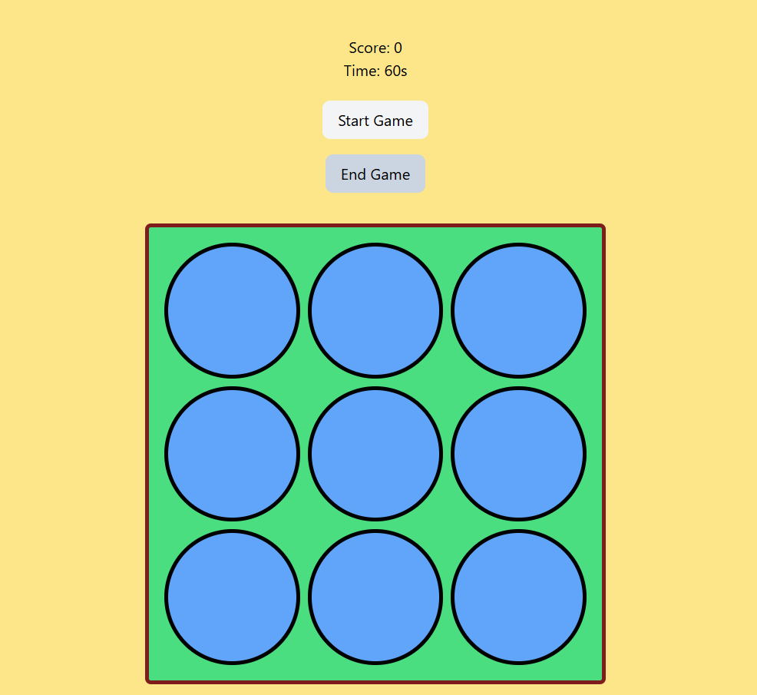

Making the mole appear (script.ts)
const holes = document.querySelectorAll<HTMLElement>(".hole");

function handleMoleClick(e: MouseEvent) {
const target = e.currentTarget as HTMLElement;
target.classList.remove("mole");
}

function popMole() {
holes.forEach(hole => {
hole.classList.remove("mole");
hole.removeEventListener("click", handleMoleClick);
});

const randomHole = holes[Math.floor(Math.random() * holes.length)] as HTMLElement;
randomHole.classList.add("mole");
randomHole.addEventListener("click", handleMoleClick);
setTimeout(popMole, 1000);
}
popMole();

Output:
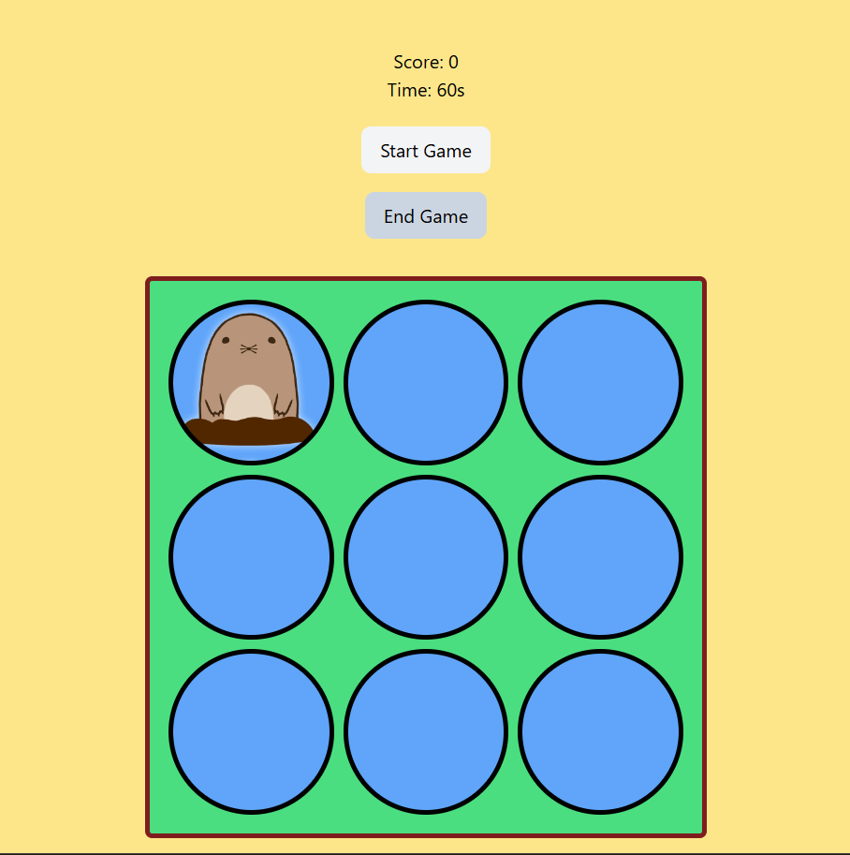

Making the whole game loop and end game mechanism

Code:
const holes = document.querySelectorAll<HTMLElement>(".hole");
const scoreElement = document.querySelector(".score-value") as HTMLElement;
const timeElement = document.querySelector(".time-value") as HTMLElement;
const startButton = document.querySelector(".start-button") as HTMLElement;
const endButton = document.querySelector(".end-button") as HTMLElement;

let score = 0;
let timeLeft = 60;

scoreElement.textContent = score.toString();
timeElement.textContent = timeLeft.toString();

let timerId: ReturnType<typeof setInterval> | null = null;
let moleTimeout: ReturnType<typeof setTimeout> | null = null;
let isPlaying = false;

function handleMoleClick(e: MouseEvent) {
const target = e.currentTarget as HTMLElement;
target.classList.remove("mole");
score++;
update();
}

function update() {
scoreElement.textContent = score.toString();
timeElement.textContent = timeLeft.toString();
}

function popMole() {
if (!isPlaying || timeLeft <= 0) return;
holes.forEach(hole => {
hole.classList.remove("mole");
hole.removeEventListener("click", handleMoleClick);
});

const randomHole = holes[Math.floor(Math.random() * holes.length)] as HTMLElement;
randomHole.classList.add("mole");
randomHole.addEventListener("click", handleMoleClick);
moleTimeout = setTimeout(popMole, 1000);
}

function startGame() {
if (isPlaying) return;

isPlaying = true;
score = 0;
timeLeft = 60;
update();

startButton.setAttribute("disabled", "true");
endButton.removeAttribute("disabled");

// button display
endButton.classList.remove("bg-slate-300");
endButton.classList.add("hover:cursor-pointer");
endButton.classList.add("hover:bg-slate-200");
endButton.classList.add("bg-gray-100");
startButton.classList.remove("hover:cursor-pointer");
startButton.classList.remove("hover:bg-slate-200");
startButton.classList.remove("bg-gray-100");
startButton.classList.add("bg-slate-300");

timerId = setInterval(() => {
timeLeft--;
update();

if (timeLeft <= 0) {
endGame();
}
}, 1000);

popMole();
}

function endGame() {
isPlaying = false;

if (timerId) clearInterval(timerId);
if (moleTimeout) clearTimeout(moleTimeout);

endButton.setAttribute("disabled", "true");
startButton.removeAttribute("disabled");

// button display
startButton.classList.remove("bg-slate-300");
startButton.classList.add("hover:cursor-pointer");
startButton.classList.add("hover:bg-slate-200");
startButton.classList.add("bg-gray-100");
endButton.classList.remove("hover:cursor-pointer");
endButton.classList.remove("hover:bg-slate-200");
endButton.classList.remove("bg-gray-100");
endButton.classList.add("bg-slate-300");

holes.forEach(hole => {
hole.classList.remove("mole");
hole.removeEventListener("click", handleMoleClick);
});
}

startButton.addEventListener("click", startGame);
endButton.addEventListener("click", endGame);

Output:
